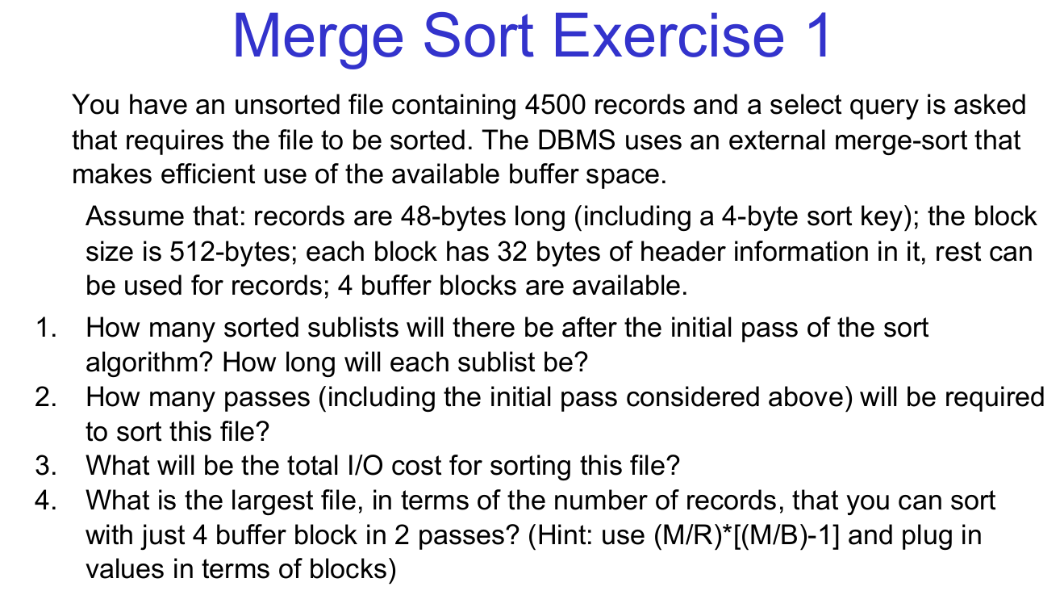
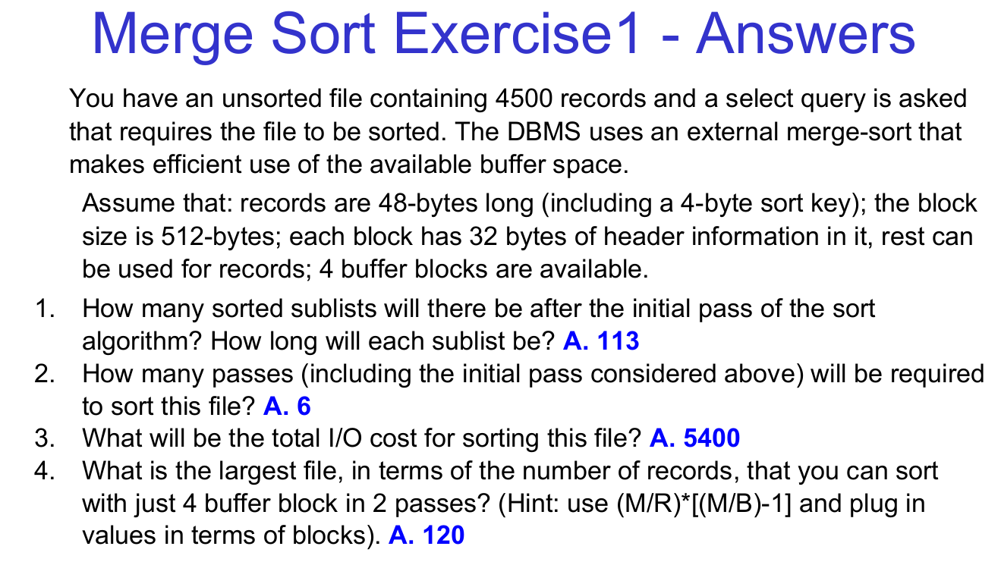

Given Data:
- Total Records: 4500. Record Size: 48 bytes (including a 4-byte sort key). Block Size: 512 bytes
- Header Size per Block: 32 bytes. Usable Space per Block: 512−32=480 bytes
- Number of Buffer Blocks: 4
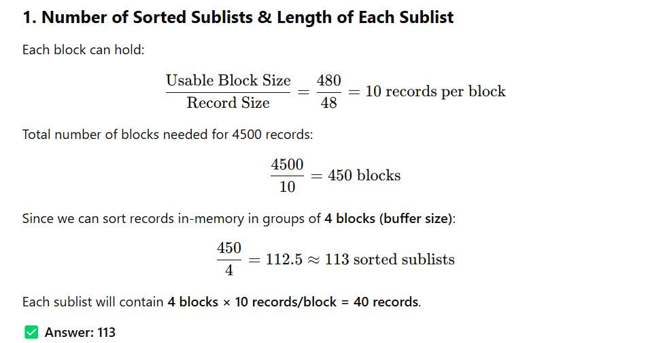
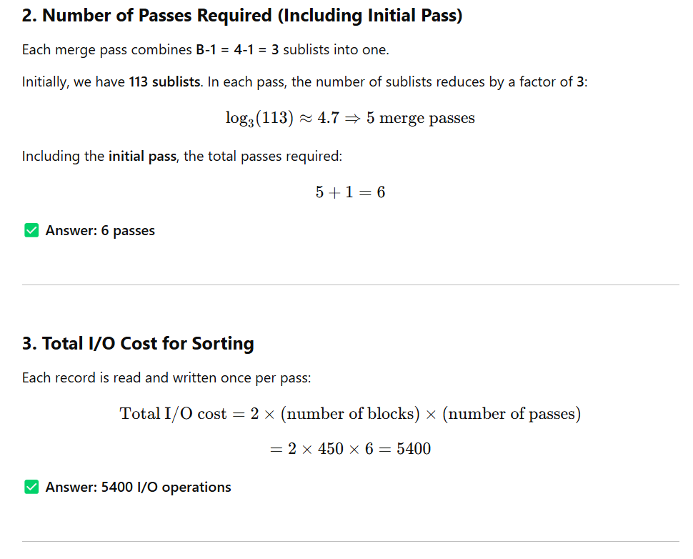
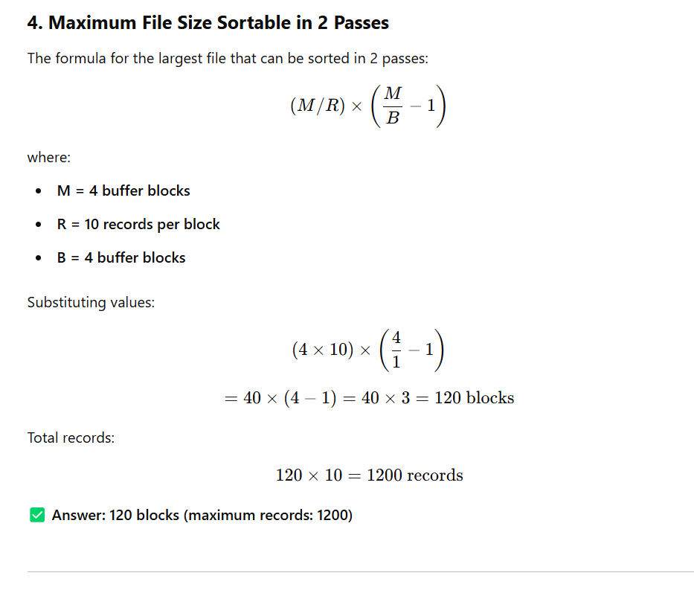
Final Verified Answers:
- 113 sorted sublists, each containing 40 records.
- 6 passes (including the initial pass) are needed.
- Total I/O cost = 5400 I/O operations.
- The maximum file that can be sorted in 2 passes = 120 blocks (1200 records).

Merge Sort Exercise 2
You have an unsorted file containing 6000 records, and a select query requires sorting the file. The DBMS uses an external merge-sort that efficiently utilizes available buffer space.

Assumptions:
- Record size: 60 bytes (including a 5-byte sort key). Block size: 1KB.
- Header size: 64 bytes per block (remaining space for records). Buffer blocks: 5.

Questions:
- How many sorted sublists will there be after the initial pass? How long will each sublist be?
- How many passes (including the initial pass) are required to sort this file?
- What will be the total I/O cost?
- What is the largest file (in terms of the number of records) that you can sort with just 5 buffer blocks in 2 passes? (Use the formula: (M/R)∗[(M/B)−1] and plug in values in terms of blocks).

Merge Sort Exercise 3
An unsorted file contains 8000 records, and a select query requires the file to be sorted. The DBMS applies an external merge-sort efficiently.

Assumptions:
- Record size: 40 bytes (including a 6-byte sort key). Block size: 512 bytes.
- Header size: 32 bytes per block. Buffer blocks: 3.

Questions:
- How many sorted sublists will there be after the initial pass? How long will each sublist be?
- How many passes (including the initial pass) will be required to sort this file?
- What will be the total I/O cost?
- What is the largest file that can be sorted with 3 buffer blocks in 2 passes? (Use the given formula and solve using block values).

Merge Sort Exercise 4
You have an unsorted file with 12,000 records, and a select query requires sorting. The DBMS uses an external merge-sort efficiently.

Assumptions:
- Record size: 50 bytes. Block size: 1KB. Header size: 64 bytes per block. Buffer blocks: 6.

Questions:
- How many sorted sublists will there be after the initial pass? How long will each sublist be?
- How many passes (including the initial pass) are required?
- What will be the total I/O cost?
- What is the largest file that can be sorted with 6 buffer blocks in 2 passes?

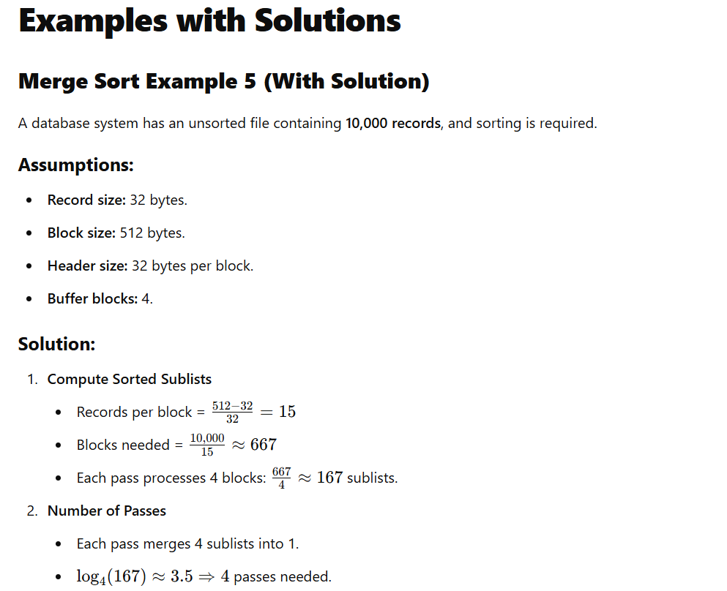
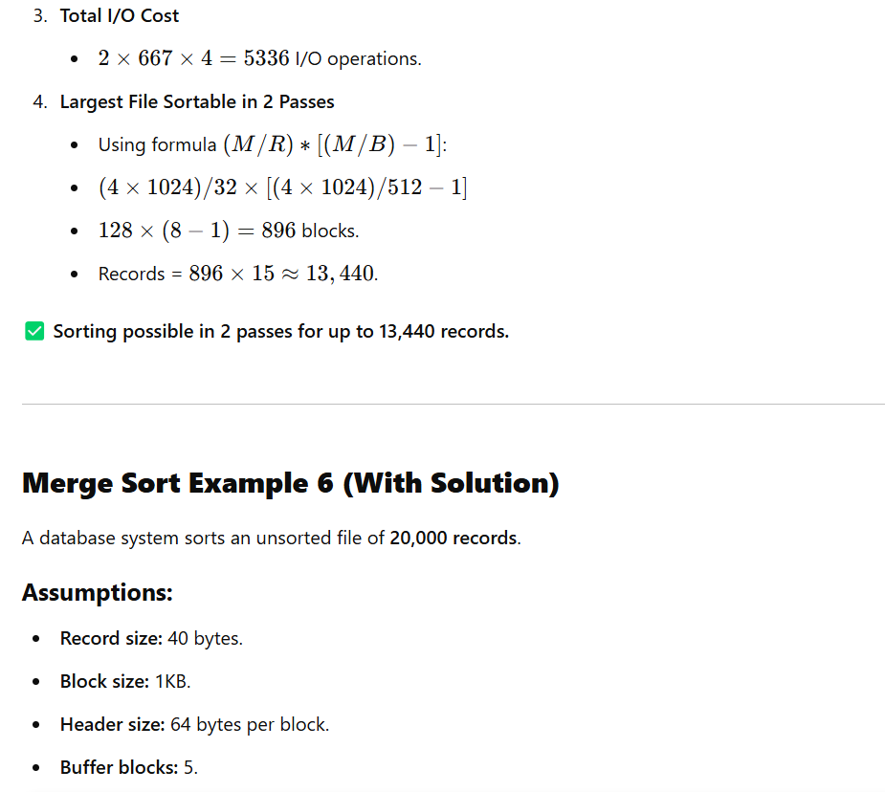
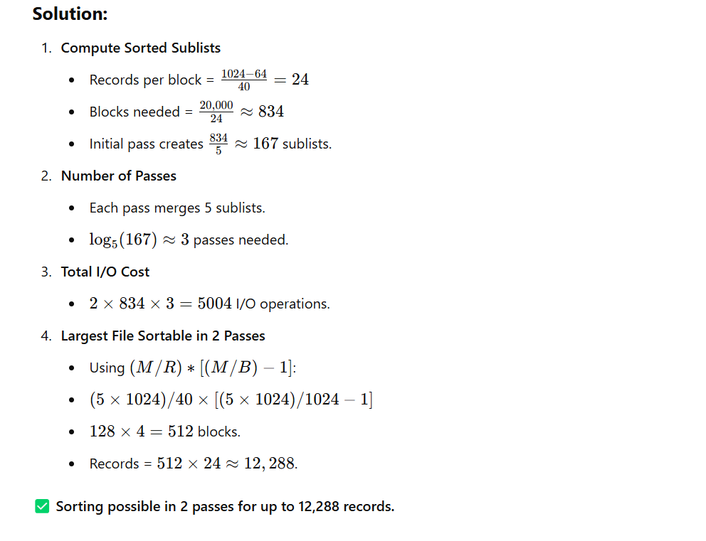

write three similar questions like in this photo
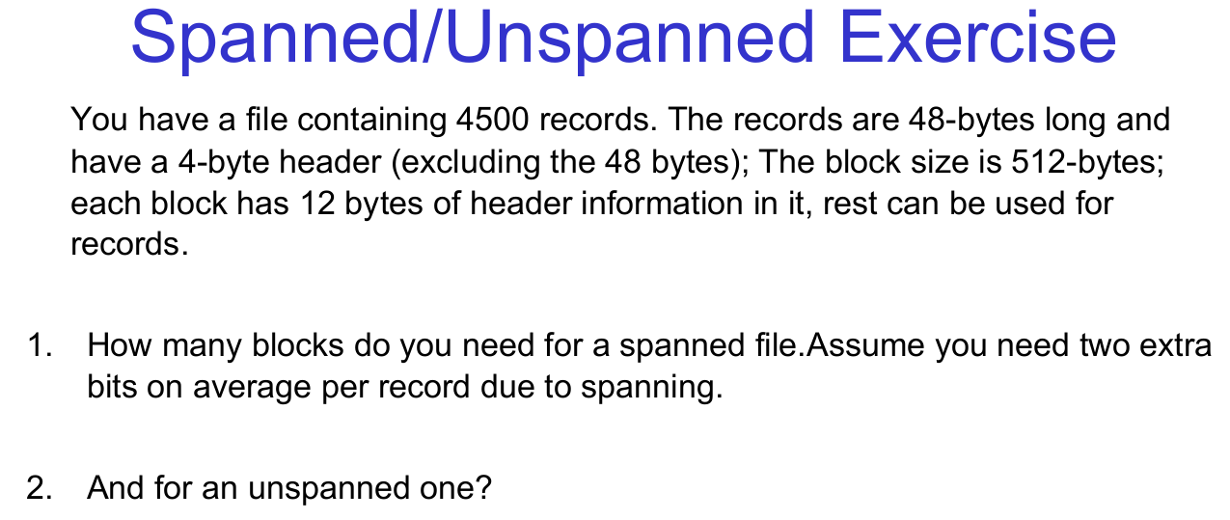

Given Data
- Total records: 4,500
- Record size: 48 bytes (data) + 4 bytes (header) = 52 bytes per record
- Block size: 512 bytes
- Block header: 12 bytes
- Usable space per block: 512−12=500 bytes
- Spanned overhead: 2 extra bits per record (converted to bytes: 2 bits=0.25 bytes)

1. Spanned Storage
In spanned storage, records can span across multiple blocks. This means a record can start in one block and continue into the next. However, this introduces some overhead due to the need to manage the spanning.

Step 1: Calculate Total Size of All Records
- Each record has:
  - Data + Header = 52 bytes
- Total size for all records: 4500×52 = 234000

- Step 2: Calculate Number of Blocks
- Usable space per block: 500 bytes
- Number of blocks required:
Number of blocks=⌈Total size of all records / Usable space per block⌉= 468 Blocks

Final Answer for Spanned Storage: 468 blocks

2. Unspanned Storage
In unspanned storage, records cannot span across blocks. Each block can only store complete records, and any leftover space in a block is wasted.

Step 1: Calculate Number of Records per Block
- Usable space per block: 500 bytes
- Record size: 52 bytes
- Number of records per block:
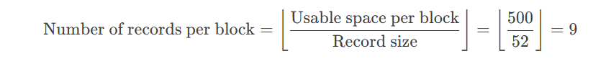

Step 2: Calculate Number of Blocks
- Total records: 4,500
- Number of blocks required:


Final Answer for Unspanned Storage: 500 blocks

Key Differences Between Spanned and Unspanned Storage
- Spanned Storage:
  - Records can span across multiple blocks.
  - More space-efficient, as no space is wasted.
  - Requires additional overhead to manage spanning.
- Unspanned Storage:
  - Records cannot span across blocks.
  - Less space-efficient, as leftover space in a block is wasted.
  - Simpler to implement, as no spanning management is needed.

Here are three similar exercises on spanned and unspanned storage:

Exercise 1
You have a file containing 6,000 records. Each record is 60 bytes long with a 6-byte header (excluded from the record size). The block size is 1,024 bytes, and each block has 16 bytes of header information. For spanned storage, assume an average of 4 bits of overhead per record due to spanning.
- How many blocks are needed for a spanned file?
- How many blocks are needed for an unspanned file?
Answer:
- Spanned: 396 blocks
- Unspanned: 400 blocks

Exercise 2
A file has 3,000 records. Each record is 36 bytes long with a 3-byte header. The block size is 256 bytes, and each block has 8 bytes of header information. For spanned storage, assume 1.5 bits of overhead per record.
- How many blocks are needed for a spanned file?
- How many blocks are needed for an unspanned file?
Answer:
- Spanned: 496 blocks
- Unspanned: 500 blocks

Exercise 3
A file contains 7,500 records. Each record is 72 bytes long with a 5-byte header. The block size is 4,096 bytes, and each block has 24 bytes of header information. For spanned storage, assume 3 bits of overhead per record.
- How many blocks are needed for a spanned file?
- How many blocks are needed for an unspanned file?
Answer:
- Spanned: 142 blocks
- Unspanned: 150 blocks

Methodology for All Exercises
- Unspanned Storage:
  - Usable block space = Block size - Block header.
  - Records per block = Floor(usable space / total record size).
  - Total blocks = Ceil(total records / records per block).
- Spanned Storage:
  - Total data per record = Record size + Header + Overhead (converted to bytes).
  - Total data = Total records × total data per record.
  - Total blocks = Ceil(total data / usable block space).

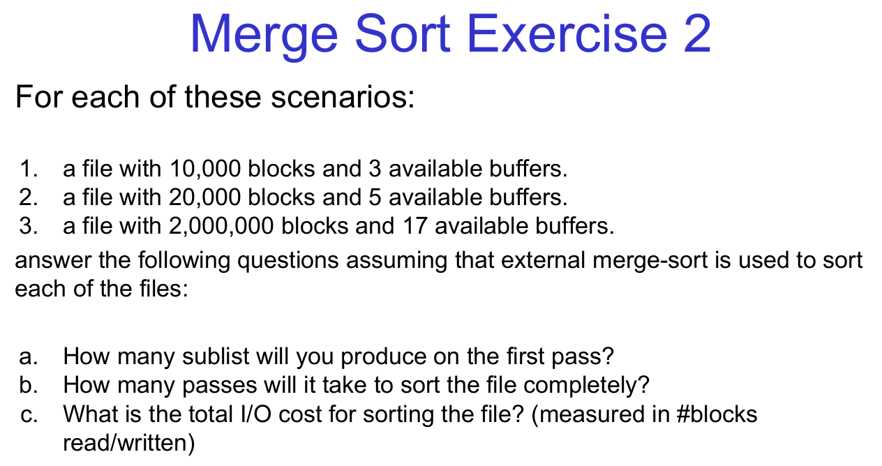

Key Concepts
- External Merge Sort:
  - Used when the data to be sorted is too large to fit in memory.
  - Divides the file into smaller sublists, sorts them, and merges them in passes.
- Buffers:
  - The number of buffers determines how many sublists can be merged in one pass.
  - One buffer is reserved for the output, and the rest are used for input sublists.
- Passes:
  - Each pass involves reading and writing all blocks of the file.
  - The number of passes depends on the number of sublists and the number of buffers.
- I/O Cost:
  - Each pass reads and writes all blocks of the file.
  - Total I/O cost = 2×Number of blocks×Number of passes

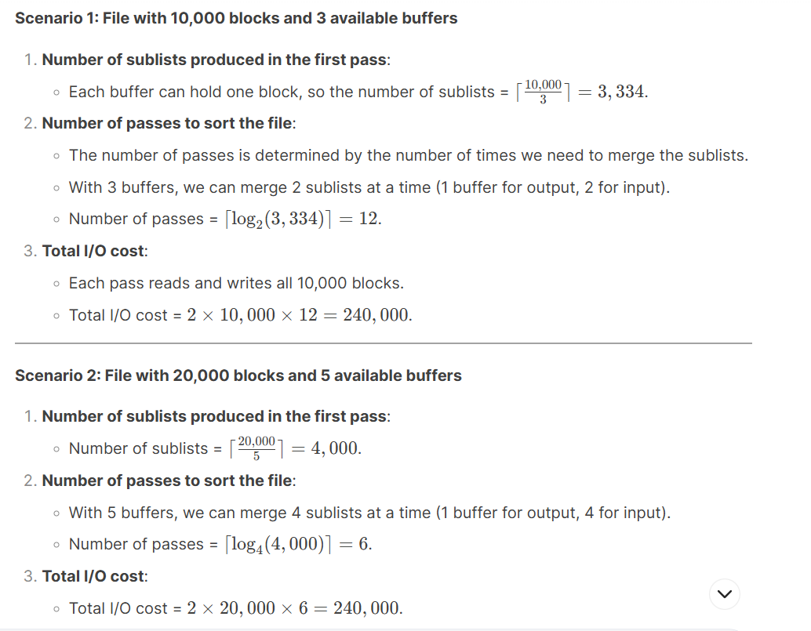

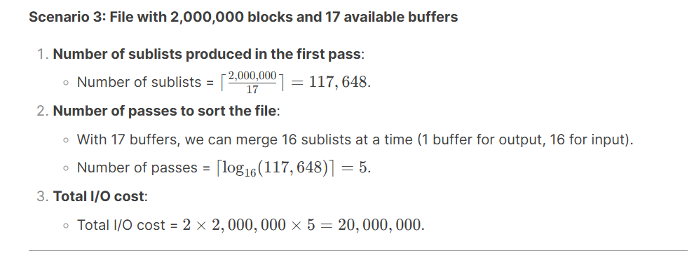

🔹 Exercise A
Suppose a record has the following fields in this order:
- A character string of length 12,
- A short integer (2 bytes),
- A double precision float (8 bytes),
- An SQL timestamp (12 bytes).
How many bytes does the record take if:
a) Fields can start at any byte.
b) Fields must start at a byte that is a multiple of 4.
c) Fields must start at a byte that is a multiple of 8.

🔹 Exercise B
Assume the fields are as in Exercise A, but records also have a record header consisting of:
- a status flag (1 byte),
- a record ID (4 bytes),
- a pointer to next record (8 bytes).
Calculate the record length for the three situations regarding field alignment (a) through (c) in Exercise A.
(Hint: Remember to round header elements as well.)

🔹 Exercise 5a
Suppose records are as in Exercise 12.2.1 (string 15 bytes, integer 2 bytes, date 10 bytes, time 8 bytes), but each record also has a record header of 6 bytes.
We want to pack as many records as possible into a block of 2048 bytes, using a block header of five 4-byte integers.
How many complete records can we fit into a block in each of the three situations regarding field alignment (a), (b), and (c) of Exercise 12.2.1?

🔹 Exercise 5b
Suppose records are as in Exercise 12.2.3 (two 4-byte pointers, a character, plus the fields from 12.2.1).
We want to pack as many records as possible into a block of 8192 bytes, using a block header that consists of eight 4-byte integers and one timestamp (8 bytes).
How many records can we fit into a block in each of the three alignment cases (a), (b), and (c) from Exercise 12.2.1?

